The Instruction of Spy DVR Watch

1. Preface:
Thank you for purchasing this product. Under the guidance of this manual, you may use this item and the subsidiary application procedures properly. Please read the manual carefully before using, so that you can operate it correctly and freely.

2. Functions summary:
①. Video Format:AVI
②. Photograph Dimension:
352*288/640*480/720*480/720*576
③.Memory: 1GB/2GB/4GB/8GB/16GB (Optional)
④. Video Recording Function
⑤. USB: 2.0(Hs)
⑥. Built-in Li-Battery: working 2 hours continuously (Max)
⑦. No need for driver installation if the operating system is Windows ME/ 2000/ XP/ Mac OS 9.2.2 or above (windows98 is excepted)

3. Charging:
①. Built-in rechargeable Li-Battery, this DVR clock can be charging while its USB plug is connected with charger or inserted into the USB port of PC. Once connected correctly, the green light of this DVR clock will be in work. When the light is off, which means the battery is in full capacity, then stop charging.
②. If there is not enough power supply while photographing, the camcorder will be power off automatically. The system will store the photography files automatically before being power off to ensure their safety.

4. Appearance & Keys:
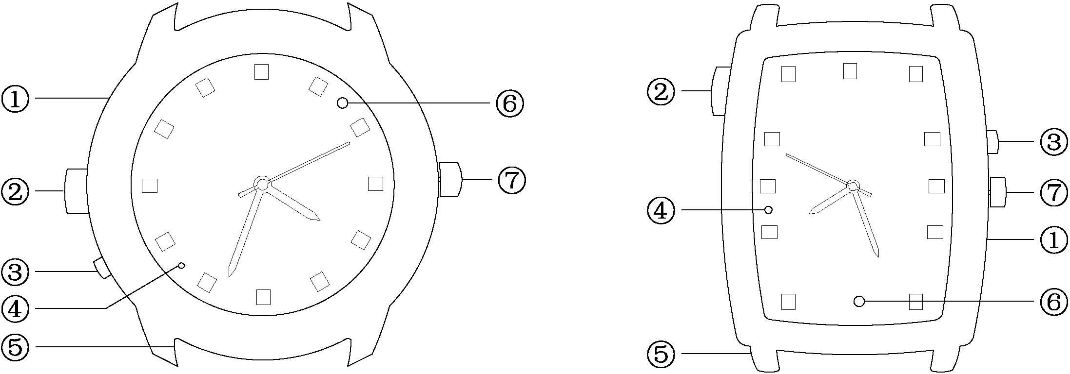

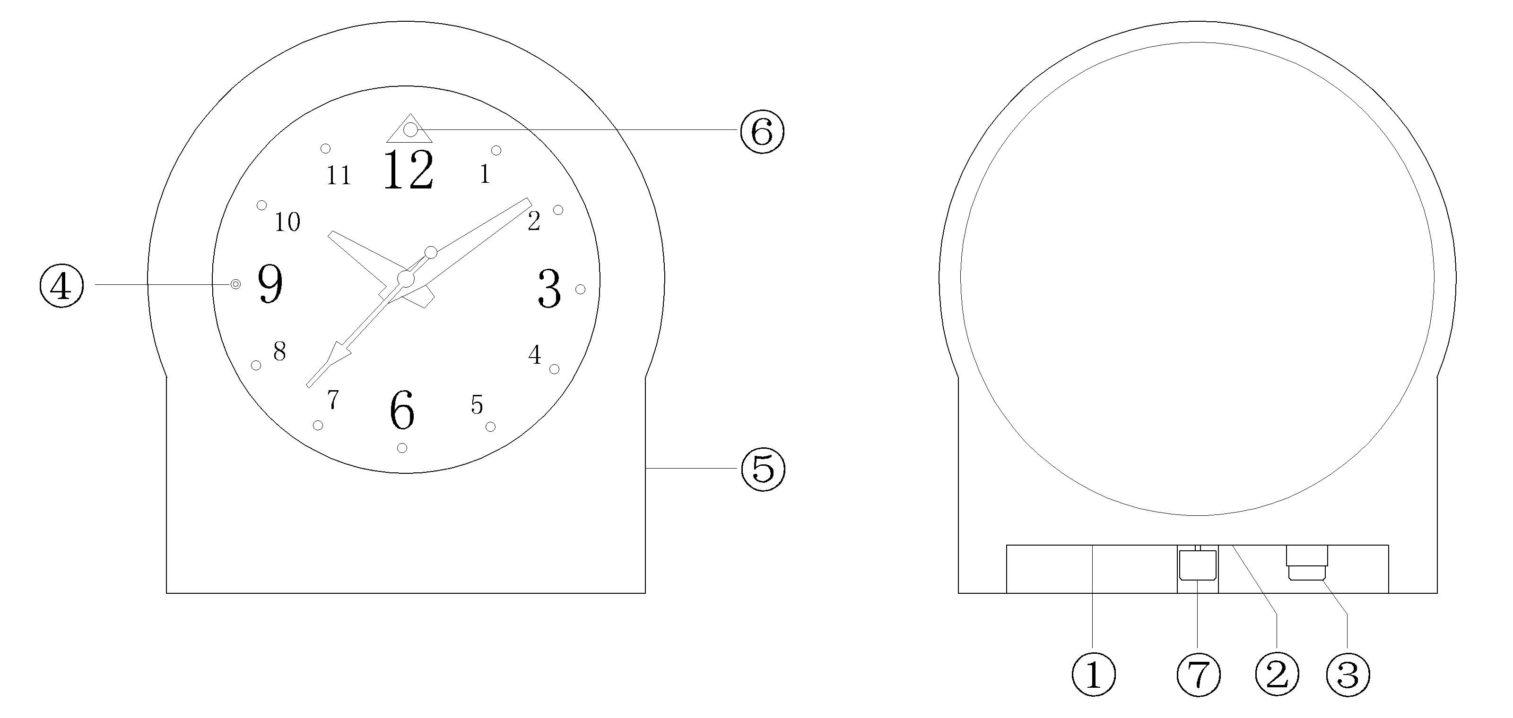

①.Reset Key ②. USB Port
③. Play/Photograph/Pause/OFF Key
④. LED ⑤. MIC
⑥. Camera ⑦. Time adjustment Key

5.Method of Operation:
①. Power-on: long press the ON/OFF button about two seconds. It has entered into the photograph mode when the green light is on. It will be photographing after the green light twinkles for three times in five seconds. Shortly press ON/OFF button to save the video and turn off the player.
②. Power-off: long press the ON/OFF button for three seconds. the host will save the file then power off, at this time, the red light twinkles three times.
( P.S. : The player will automatically turn off when it is lack of disk space.)
③. Reset Key: Please press the Reset Key to restart when the player crashes.
④. Time: Local video files with time watermarks. It can be modified, when the equipments come out from factory, we did not adjust the time, if you find it is not accurate , it's easy to adjust by yourself, just use the USB cable to connect the equipment to the computer, at the same time, running the CD-ROM. Find the file named "GetSysTime exe",click "getsystem time exe" to confirm,then pull out the host. The time of the equipment will be synchronize with the time of computer when you use it again.

6. Driver Installation:
Need for Windows 98, you should install the driver CD to your computer and it will take effect after restart computer.
No need for Windows ME/2000/XP/Mac OS 9.2.2 or other system above.

7. PC Connection:
①. Connect the USB cable to the PC USB port, after being connected correctly, you can find “ removable disk” in “ my computer”.
②. When the camera watch is connected to the PC, the camera watch begins to work as the removable hard disk of the PC. You can view video files, transmit, copy, paste and delete data(audio and video files etc) conveniently, non-music files can be stored too.
③. Remove the USB device.
a. Double click the icon of “ delete the hardware safely”
b. Choose “stop” in the dialog frame after you double click “safely delete the hardware”.
c. Choose the device you want to stop, and confirm, there will be a hint “The USB mass storage Device can be removed from the system safely.”
d. Close the dialog frame of “Delete the hardware safely”
e. Remove the player from the PC

8. Notices:
①. Working Temperature: Please use it at natural temperature, do not use it at the temperature that human being can not adapt to.
②. Recording Illumination: Please use it at the environment with enough light. Do not directly face the super strong light, ,such as the sun light to avoid damaging the optical devices.
③.Others:The product belongs to sophisticated electronic products, Please do not let it subject to strong impact, vibration. Do not use it in strong magnetic filed.

9 . Trouble-shooting:
①. Can not turn on
Check if the battery is short of power, Please charge the player

②. Can not download and upload files normally
a. Check if the USB cable between the player and the PC is in good condition and is connected correctly.
b. Check if the installation of the drive is proper (under Windows 98)
c. Check if the player has enough space to store music files.

