This is the quick start guide for Helmet Camera (VSDSP-360AVI)

- Product display：
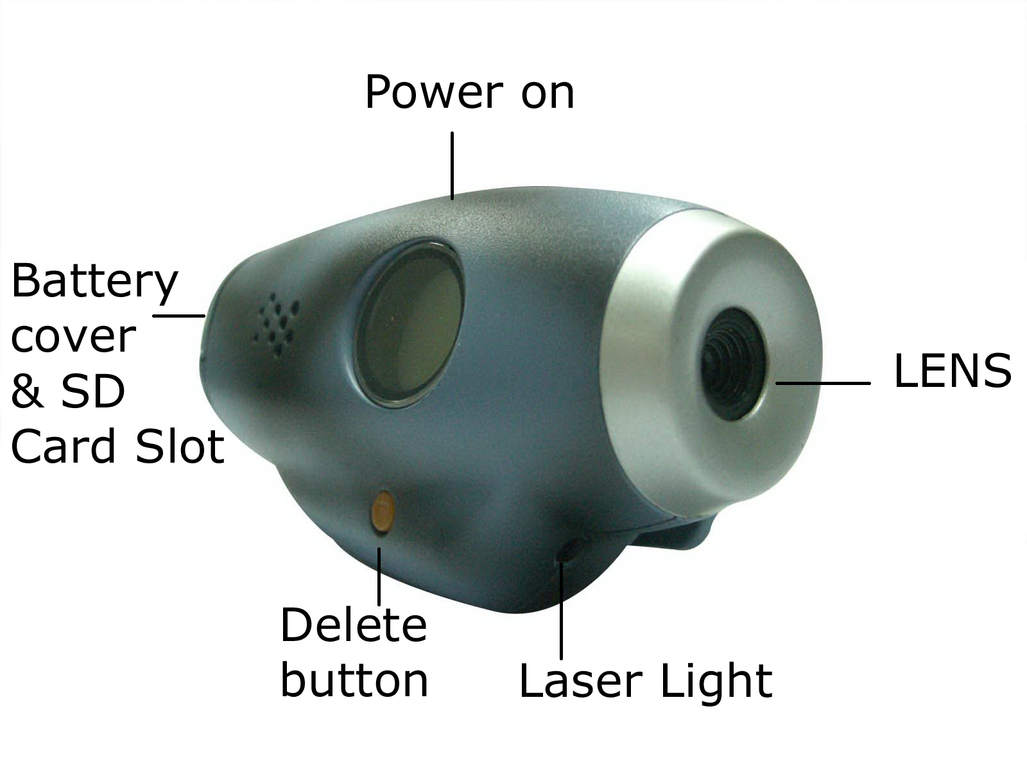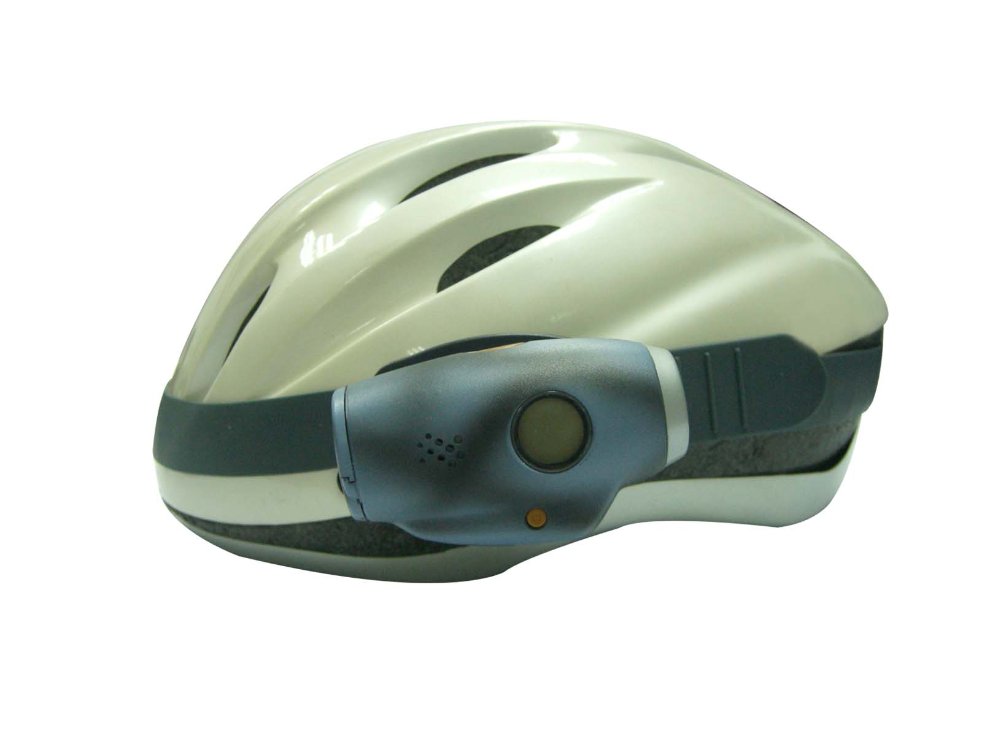

- First step：Open battery cover and insert 2 1.5V AAA battery. Make sure positive and negative of the battery and connected in correct manner. Remember there is no memory built in, so SD card is required for video recording.

- Press power on button, a logo of camera will be displayed within the LCD screen, and Laser light will be blinking. The camera is now working, but pressing the power on button one more time is required for video recording. The Laser light will stop blinking and logo of camera will start to flop, it is a sign that video recording has just started.

- Video recording time will be max 15 minutes per segment. A “beep” sound will be announced after 15 minutes indicates the segment is completed. Logo of camera will stop to flop and pressing power on button again will start second video recording

- Two method of playing back video recording:

1）Remove the SD Card, and connect it to PC via card reader. Data can be read and write from the card reader
2）Press hold of power on button, connect to PC via USB cable. A new drive will be formed and will be used for data reading and writing

- PC camera function: Install Driver and connect the camera to PC via USB cable. Once installation completed, you can start video conferencing.

- Power off：
1）No command or action given in one minutes, camera auto shut down
2）Manual power off required to take out battery

Remarks：We only provide helmet camera and accessories (Batteries and Helmet is not included)

