Mini Pen Interview Recorder
User Manual
Introduction
Thank you for purchasing your mini interview recorder. Ideal for both
spy camera & hidden camera, small enough to conceal almost anywhere!
Wherever you place your mini camera, you’ll know for sure that you
won’t miss anything

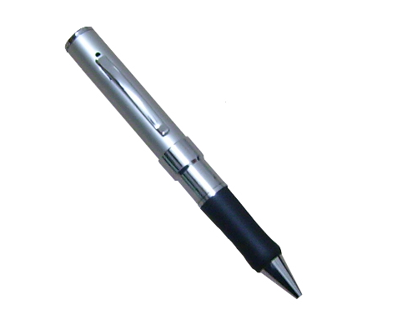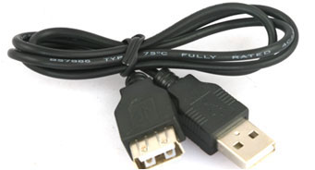
What your mini interview recorder includes?
- Mini interview recorder
- USB cable
- USB manual
Features
- Dimension:150mm*15mm*15mm
- Weight:30g
- Tiny size makes it ideal for a variety of uses.
- It’s great for use as a hidden cam, spy cam , etc.
- Real time recording in AVI video format
- Color video with voice lets you clearly see who’s there & hear what they say.
- Place it up high or conceal it down low. With built-in rechargeable
1
battery so there’s no long cord for you to hide.
- Internal memory:4 GB or 8 GB
- Playback video on PC
Camera Technical Parameter
- Video compression : AVI video format,640*480 30FPS
- Voice recording: Yes
- Internal memory: Yes
- Flash:4 GB or 8 GB
- Video file size; >500KB per min
- Recording mode :continuous recording until memory is full or manually off
- Adaptor type: USB adaptor charging cable
- Battery type : Lithium-ion
- Record time : up to 5h
- Battery use time : about 3h
A Quick Look at your Mini Pen Interview Recorder
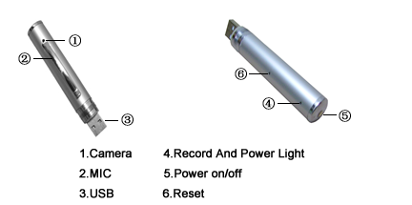
Starting your Mini Pen Interview Recorder
2
Step 1:
Press the switch, it begins to kinescope as soon as being turned on. The blue light will turn on during kinescoping.
Step 2:
Press the switch again, it will begin to save data and then turn off, at this time, the light turns to yellow, reflect that the pen DVR is at sleeping status(that means do not kinescope or shut down neither).
Step 3:
If need to kinescope again, press the switch once more, then can come back to kinescope , during this time ,the light will turn to blue again.
Step 4:
Hold down the switch for 5s , then the power switch is off ,after shutting down the pen DVR , there is no guide light.
Step 5:
When finish charging the battery , the light stops glittering and the yellow light keeps on ,which means that battery is fully charged.
Step 7:
It will turn off itself when the battery has been used up. And will save the kinescoped files before automatically shutting down.
Brief introduction
- The fewest mini DVR in the world which conceals in the pen .And the first mini pen DVR with the function of both kinescope and record.
- The high fidelity microphone can record the sound around 15㎡.And the high clear kinescope can help the police and court to get evidence.
- The fancy aspect , smooth pen writing function ,exchangeable standard lead is all durable and environmental.
- Suitable for any computer and electron device with USB port. USB2.0 standard port, need no drive or circumscribed electric power source neither.
- 2 million pixels for the camera.
3
Connect to PC with USB cable
- Connect the machine to the computer with USB cable. The machine is in the state of charging while the yellow light is twinking.(You can also directly charge the camera using an adaptor accorded with the specifications of USB).Charging 2 hours is necessary.
- Function as removable disk when connect the camera to PC, playback the video files stored flash via the computer.(Free download the KMplayer software from the http://imgcdn.pandora.tv/pan_img/KMP/Download/kmp.exe).
- Advice use the charger

FAQ
Q : Can the video file which is recording be stored if the battery is out suddenly during using?
A : Don’t worry . if the battery use off suddenly it will store the recording video files before it turns off.

Q : How to deal with the situation of system halted?
A : Please use “RESET” button then push the on/off switch , so it will work again.

Q : Which form can be chosen to format?
A : Please use form “FAT” to format.

Attention
Do not switch “RESET” button when the machine is recording , otherwise the data won’t be saved.

4

