The Instructions of DVR mini metal desk clock
Ⅰ. Preface
Thank you for purchasing this product. Under the guidance of this manual, you may use this item and the subsidiary application procedures properly. Please read the manual carefully before using, so that you can operate it correctly and freely.

Ⅱ. Functions summary:
● 300K Pixels
● Photograph Format: AVI
● Photograph Dimension: 640*480
● Memory: 512MB/1GB/2GB/4GB/8GB (Optional)
● Video Recording Function
● USB: 2.0(Hs)
● Built-in Li-Battery: working one and a half hours continuously (Max)
● No need for driver installation if the operating system is Windows ME/ 2000/ XP/ Mac OS 9.2.2 or above (windows98 is excepted)

III.Appearance & Keys:
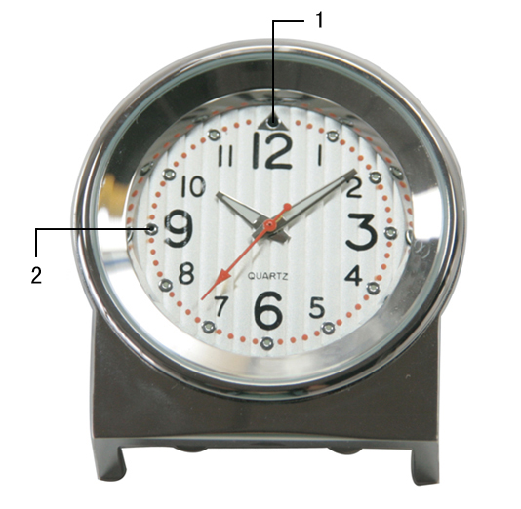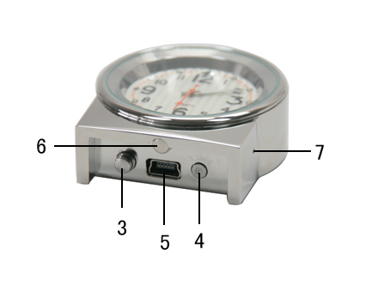
- Camera
- LED light
- Power on/off /Recording/Saving Key
- Reset Key
- USB port
- Time adjustment
- MIC
IV.Method of Operation:
- Power-on: long press the POWER key about two seconds until the LED light turns to be green. About eight seconds the green light will twinkle three times then off which means the DVR clock is recording videos
- Power off: Long press POWER key for three seconds to save the video and power off when the red light twinkles three times.
( P.S: The DVR will automatically turn off when lack of disk space.)
- Reset Key: Press the reset key to delete the current video files if no need for saving the current video files.( The previous video files will not be deleted)
V.Driver Installation:
Need for Windows 98: Install the driver CD to your computer and it will take effect after restart computer.
No need for Windows ME/2000/XP/Mac OS 9.2.2 or other system above.

VI. PC Connection
1. Please insert the USB cable to the device firstly and then connect it to the PC USB port, after connect correctly, you will find “ removable disk” in “ my computer”.
2. When the DVR desk clock connect to the PC, the DVR desk clock begins to work as a removable hard disk of the PC. You can view video files, transmit, copy, paste and delete data (audio and video files etc) conveniently, non-music files can be stored also.
3. Disconnect the USB device.
a. Double click the icon of “ delete the hardware safely”
b. Choose “stop” in the dialog frame after you double click “delete the hardware safely”.
c. Choose the device you want to stop, and confirm, there will be a hint “The USB mass storage Device can be removed from the system safely.”
d. Close the dialog frame of “delete the hardware safely”
e. Disconnected the DVR desk clock from the PC
VII. Charging
1. This DVR desk clock has in-built rechargeable Li-Battery, Please insert the USB cable to the DVR desk clock firstly and then be in charging when the USB plug is connected with charger or inserted into the USB port of PC. (P.S:when charging through the PC, please exit the device safely from the PC so that the device can enter into normal state of charging.)
Once connected correctly, the green light of this DVR desk clock will be in work. When green light is off and red light is on, which means the battery is in full capacity, then stop charging. Please disconnect the device from the charger or PC firstly, then take out the charger. (P.S: The clock applies rechargable Li-battery, please full charge the device after using up the battery for the previous five times using in order to activate the Max capacity of the battery and gain the standard working time.
2. If there isn’t enough power supply while video recording, the DVR will power off automatically. The system will save the video files automatically before power off to ensure their safety.
3.Please full charge the device before using if the device was not used for long time.

VIII. Video recording time setting
Please connect the device to the computer firstly and then open the file of “GetSysTime” in the removable disk. As follow:
Step1: Open the tool of time setting
Step2: The system will show the following hint:
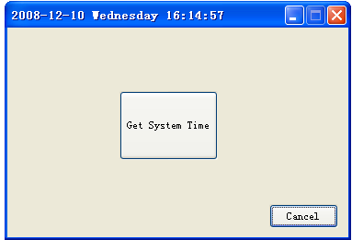

Step3: Click the “Get System Time” 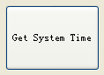button, the system will set the time automatically.
Step4: After setting successfully, the system will show hint as follow:
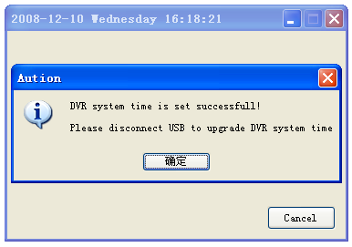
Step5:Click Confirm, then remove the USB device safely.
. Attentions
1. Working Temperature: Use the device under the nature temperature.
2. Operating humidity: Use the device under the humidity of human living, Don’t put the device under moist environment for it is not water-resistance.
3..Recording Brightness: Please use the device under the circumstance of light enough, do not point the camera to bright sunshine and other sharp light sources in avoid to demage the optical device.
4.Other warnings: This device belongs to new precision electronic product, collision and vigorous shaking are not allowed, do not use it in strong magnetic and electric fields

X. Trouble-shooting
- Can not turn on: short of power, please charge.
- Can not download and upload files normally:
A.Check if the USB cable between the device and the PC is in good condition and connect correctly.
B. Check if the installation of the drive is proper (under Windows 98)
C. Check if the device has enough space to store video files.
3. System halted：If the system halted, please press reset key to restart the device.

